📁 File Upload



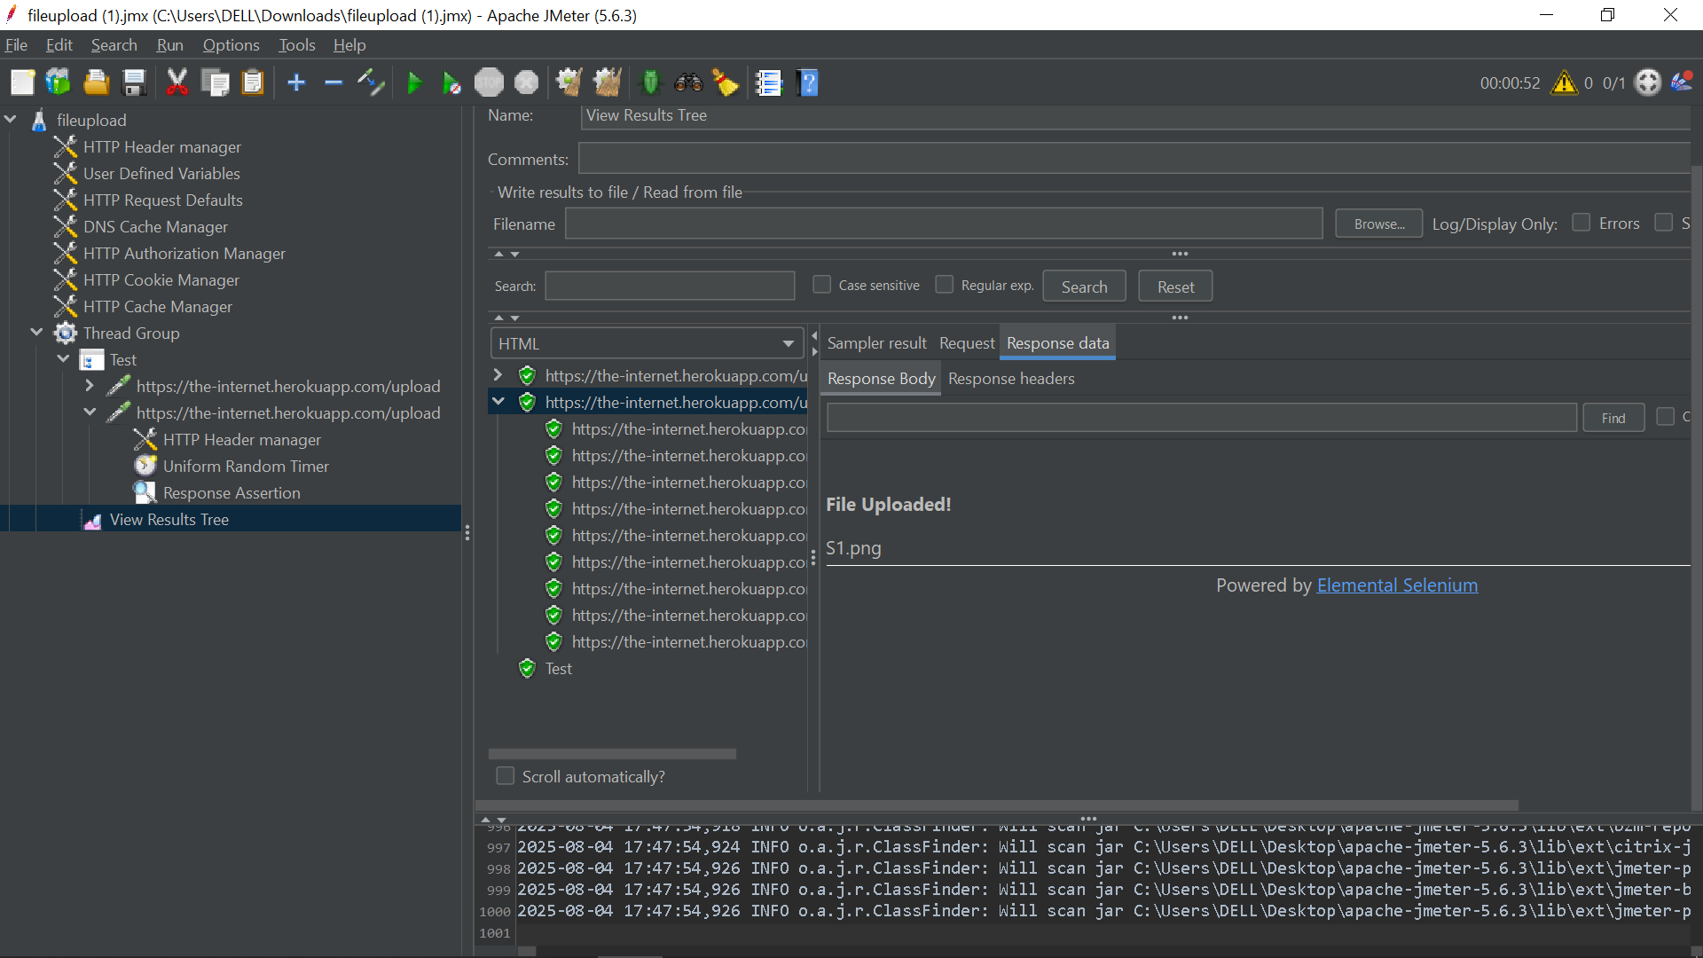

**File upload testing** is essential for validating the performance, reliability, and robustness of systems that allow users to transfer files. Apache JMeter provides an effective way to simulate and analyze how your application handles concurrent file uploads under load.

**🔍 Why is File Upload Testing Important?**

* **📈 Performance Under Load**  
  Identifies bottlenecks and performance degradation when multiple users upload files simultaneously.
* **🛡️ System Stability**  
  Validates the system's resilience under peak traffic or large file uploads.
* **❗ Error Handling**  
  Ensures proper handling of large files, unsupported formats, or failed uploads.
* **🧠 Resource Utilization**  
  Monitors CPU, memory, and disk usage to prevent overloads or crashes.

**🛠️ Step-by-Step Guide to File Upload Testing in JMeter**

**1️⃣ Create a Test Plan and Thread Group**

* Open JMeter.
* Right-click on **Test Plan** → Add → **Threads (Users)** → **Thread Group**.
* Configure:
  + **Number of Threads (users)** – Simulates concurrent users.
  + **Ramp-Up Period** – Time to start all users.
  + **Loop Count** – How many times to repeat the test.

**2️⃣ Add HTTP Request Sampler**

* Right-click on **Thread Group** → Add → **Sampler** → **HTTP Request**.
* Configure:
  + **Server Name or IP**: your.server.com
  + **Port Number**: e.g., 80 or 443
  + **Method**: POST
  + **Path**: e.g., /upload

**3️⃣ Configure File Upload Details**

* Scroll to the **Files Upload** section in the HTTP Request.
* **File Path**: Full or relative path to the file.
* **Parameter Name**: Name of the <input type="file" name="..." /> field (use browser dev tools to inspect).
* **MIME Type**: File type (e.g., image/jpeg, application/pdf, text/plain).
* ✅ Check **Use multipart/form-data for POST**.

**4️⃣ Add HTTP Header Manager *(Optional but Recommended)***

* Right-click on HTTP Request → Add → **Config Element** → **HTTP Header Manager**.
* Add headers like:
  + Authorization: Bearer token if needed.
  + User-Agent: Custom user agent if required.

**5️⃣ Add Assertions**

* Right-click on HTTP Request → Add → **Assertions** → **Response Assertion**.
* Assert:
  + **Response Code**: e.g., 200
  + **Text Response**: e.g., "Upload successful"

**6️⃣ Add Listeners for Results**

Right-click on Thread Group → Add → **Listener**, and add:

* **View Results Tree**: Inspect request/response data.
* **Summary Report**: High-level performance summary.
* **Aggregate Report**: Average, min, max response times.

**🧪 Advanced Techniques and Best Practices**

**🎬 Use HTTP(S) Test Script Recorder**

* Record real interactions via browser to auto-generate the correct request format.
* Configure JMeter proxy, upload a file while recording, and JMeter will populate samplers automatically.

**📁 Upload Multiple Files Dynamically**

Use **CSV Data Set Config** to parameterize file uploads:

* Create a .csv with columns like: file_path,param_name,mime_type
* Use ${file_path}, ${param_name}, etc., in HTTP Request fields.

**🗂️ File Path Tips**

* **Absolute Paths**: Reliable for local tests.
* **Relative Paths**: Useful in distributed setups, but all nodes must have the file in the same relative location.

**📊 Resource Monitoring**

While executing the load test:

* Use **JMeter Plugins (PerfMon, Server Agent)** or tools like **Grafana, Prometheus, or New Relic**.
* Monitor:
  + CPU usage
  + Memory utilization
  + Disk I/O
  + Network latency

**✅ Summary**

| **Feature** | **Supported in JMeter?** |
| --- | --- |
| Multipart Form Upload | ✅ Yes |
| Multiple Concurrent Users | ✅ Yes |
| Dynamic File Parameters | ✅ Yes (with CSV) |
| Error/Success Assertions | ✅ Yes |
| Record Real Uploads | ✅ Yes (Proxy Recorder) |
| MIME Type Support | ✅ Yes |